
Year 9 Mini-Test 3
Probability and Linear Relationships
Resources allowed
Calculator and a page of Notes

Name: _________________________ Date:______________ Score:______________/40

1). If a 6 sided dice is rolled, the chance of getting a 5 is? [1 Mark]
- $\frac{1}{6}$ b) $\frac{5}{6}$ c) $\frac{6}{5}$ d) 1:6
2). If a 6 sided dice is rolled, what is the chance of getting less than 4? [1 Mark]
- $\frac{1}{6}$ b) $\frac{1}{2}$ c) $\frac{2}{3}$ d) 4:6
3). If a 6 sided dice is rolled, what is the chance of getting the complement of rolling a 4? [1 Mark]
- $\frac{1}{6}$ b) $\frac{5}{6}$ c) $\frac{2}{3}$ d) 4:6

Use the following Venn diagram to complete the next 4 questions
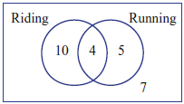
4). How many people like running? [1 Mark]
a)7 b) 9 c) 10 d) 14 e) 4 f) 26
5). How many people like riding but don’t like running? [1 Mark]
a)7 b) 9 c) 10 d) 14 e) 4 f) 26
6). How many like both running and riding? [1 Mark]
a)7 b) 9 c) 10 d) 14 e) 4 f) 26
7). How many people in total were asked if they like running or riding? [1 Mark]
a)7 b) 9 c) 10 d) 14 e) 4 f) 26

8). A family has an even chance of owning a red car, a white car or a black car. At the same time each family has an even chance of owning a dog, a cat or no pets.
  - Draw a tree diagram. [4 marks]

  - What is the sample space of possible outcomes? [1 Mark]

  - What is the probability the family owns a white car and a dog? [1 Mark]

  - What is the probability the family has a pet and a black car? [1 Mark]

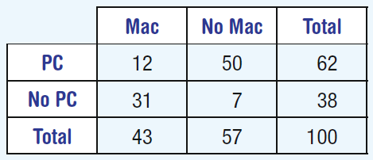
9. The Venn diagram below shows how many people own a PC computer, an Apple or both. Use this to complete the 2 way table. [3 Marks]
No Apple
Apple
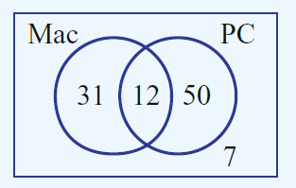
Apple
PC
No PC

10. In a class of 30 students, 22 have an Xbox and 9 have a PS4 console. Three had both an Xbox
and a PS4 console and 2 students carried neither.
- Represent this using a Venn diagram. [3 marks]

- What is the probability that a student has both an Xbox and a PS4? [2 Mark]

11. Find the gradient for each of the following. [1 Mark each = 3 marks]
- B)
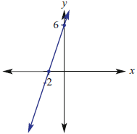
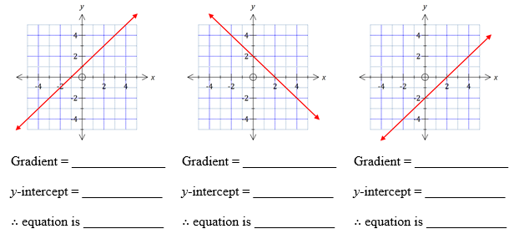

12. Find the length of the line and the coordinates for the mid point of the line for both of the following graphs [6 marks]

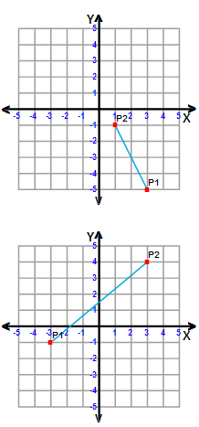
a) Length of the line =

Midpoint =

Length of the line =

Midpoint =

13. A survey of 25 000 new car buyers found that 750 had a major mechanical problem in the first year of operation. Calculate the relative frequency of:
a) having mechanical problems in the first year [1 mark]

b) not having mechanical problems in the first year [1 mark]

14. A friend has 5 snake lollies left in a bag, 2 green, 1 red and 2 yellow ones. He offers one snake each to his 2 friends.
a) Draw a tree diagram and list the possible outcomes of the possible choices for the 2 friends. [5 marks]

Friend 1 Friend 2 Outcomes
Green
Green
Red
Yellow
Yellow
Green
Red
Yellow
Yellow
Green
Red
Yellow
Yellow
Green
Green
Yellow
Yellow
Red
Green
Green
Yellow
Green
Green
Red
Yellow

If the first friend actually takes and eats 2 snakes, 1 green and 1 yellow, what are the chances of the second friend getting the red snake? [2 mark]

End of Test

